Certification Microservices Project

Outputs:

<http://localhost:8082/hello-client>

running issuems application

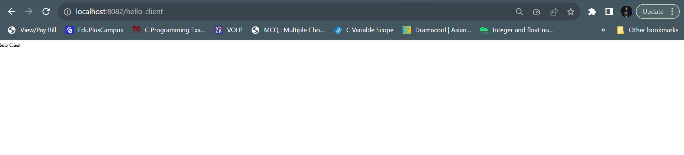

<http://localhost:8081/books>

running bookms application

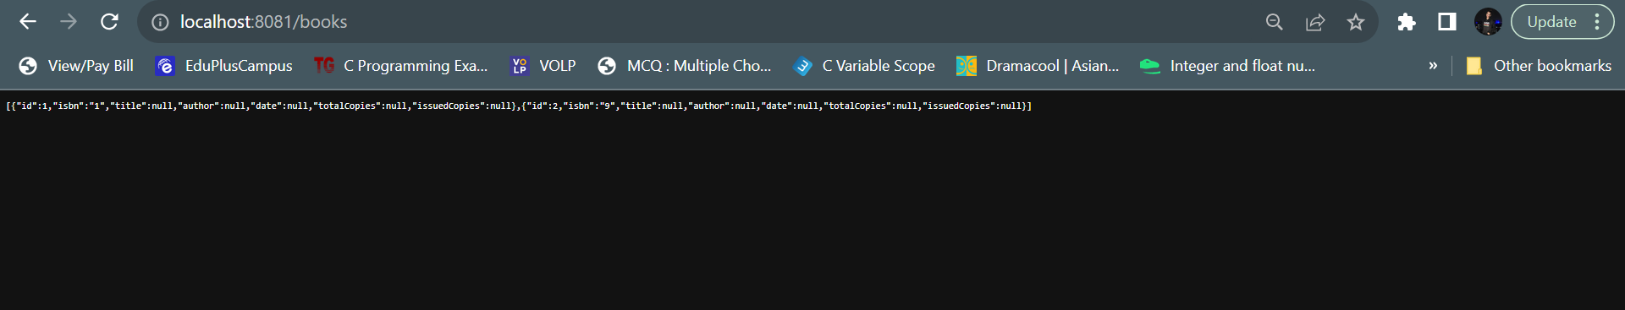

On swagger, trying all endpoints

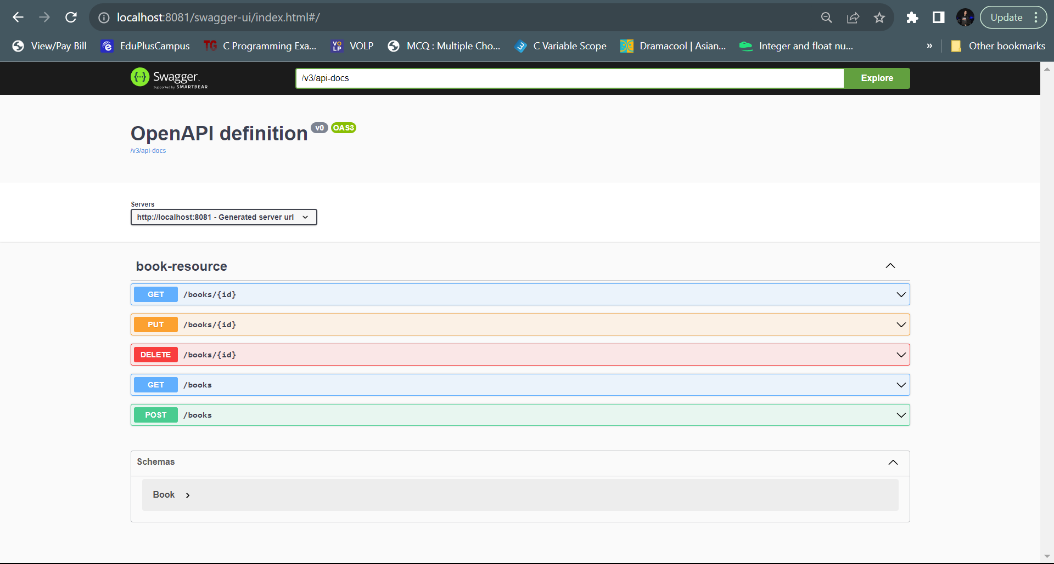

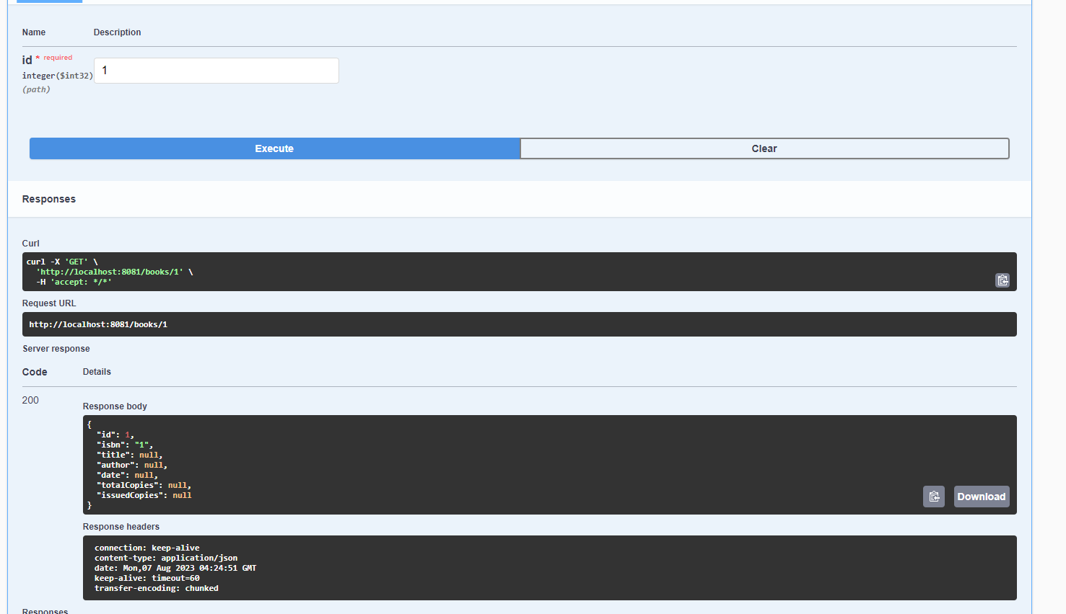

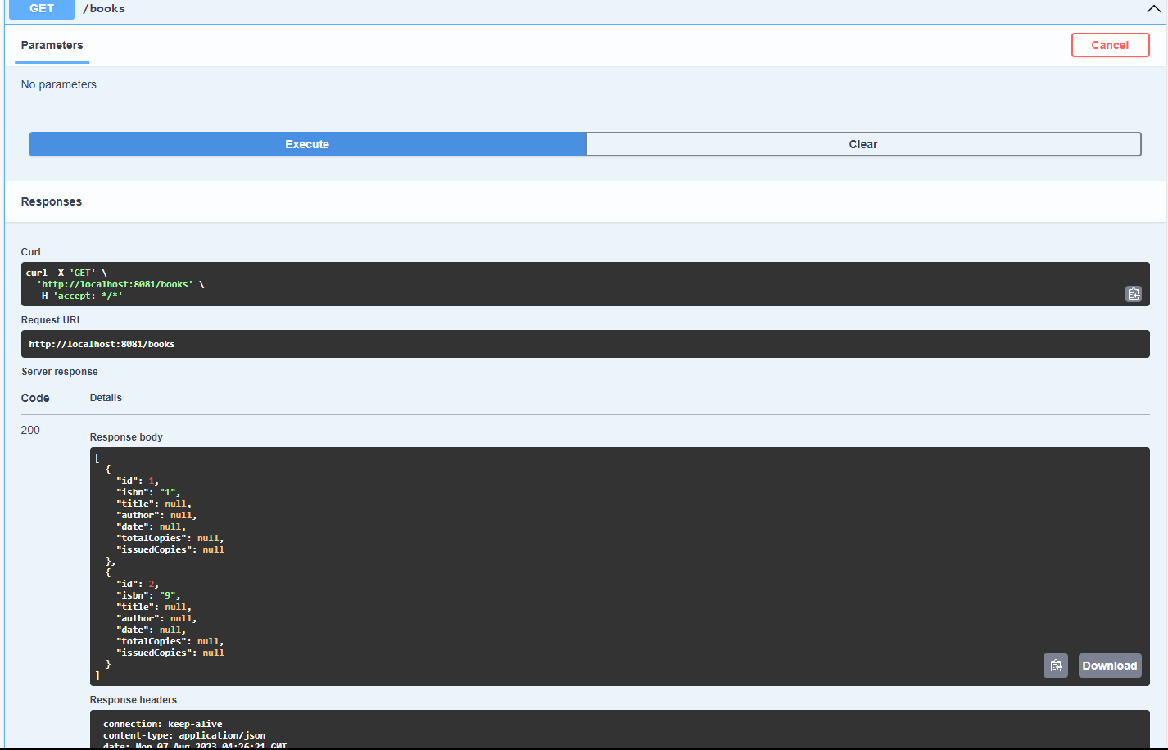

Accessing books from apigateway port,8080

<http://localhost:8080/dummy-bookms/books>

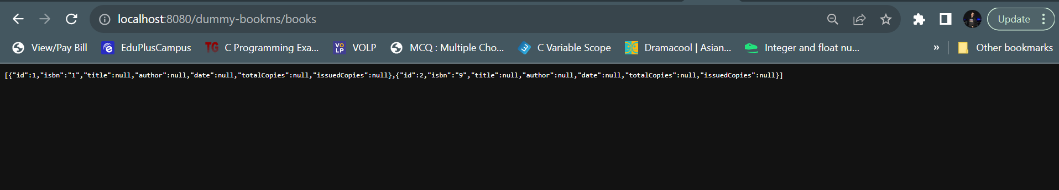

<http://localhost:8761/>

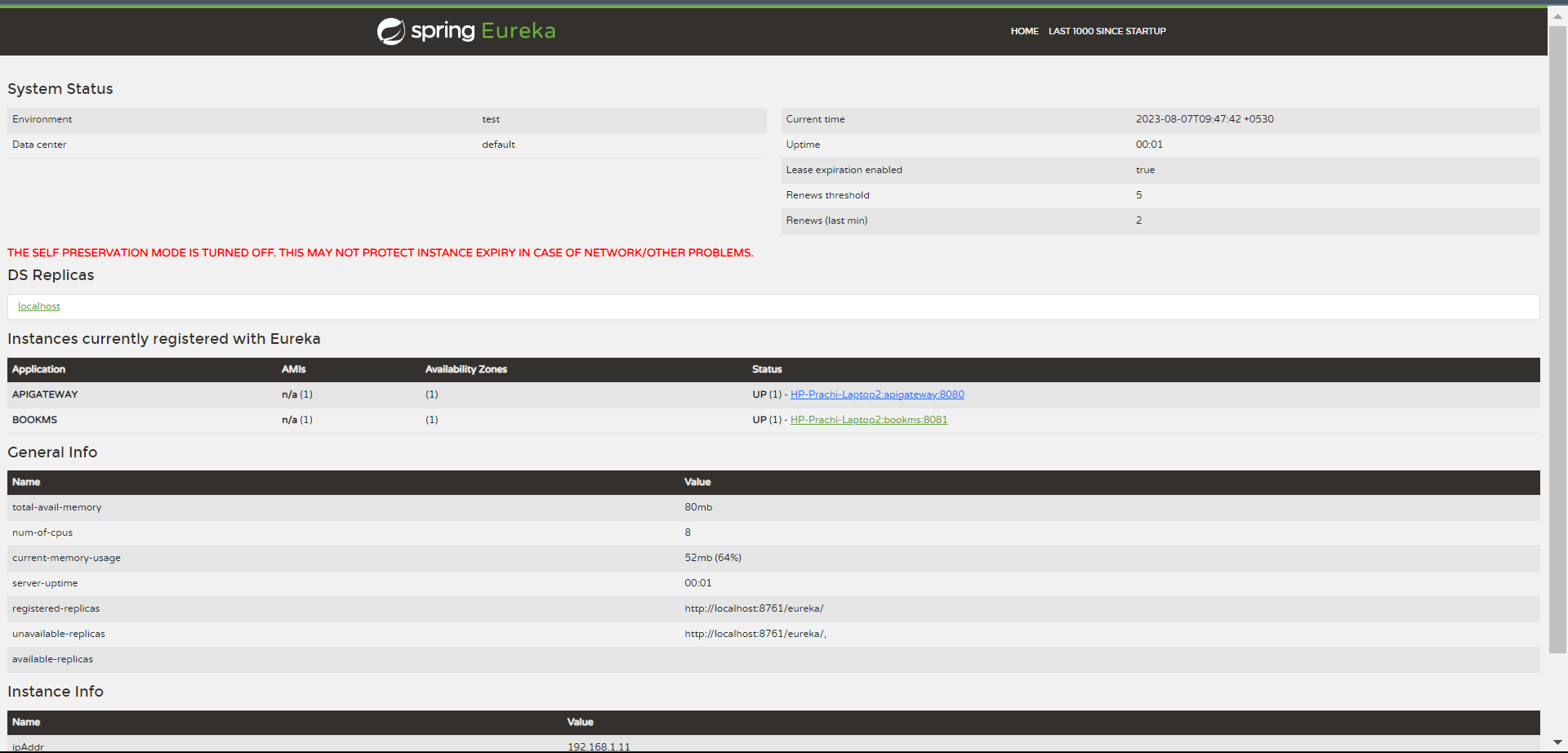

Actuator working from apigateway service, metrics can be seen

<http://localhost:8080/actuator>

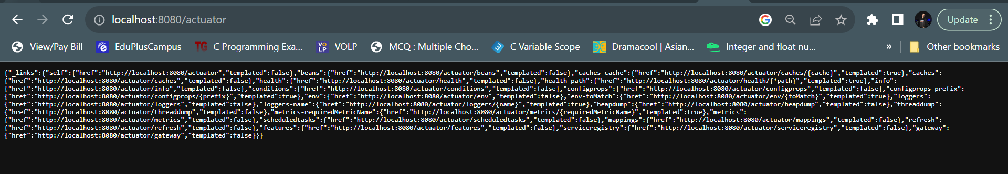

Our oauth server is up:

<http://localhost:8761/>

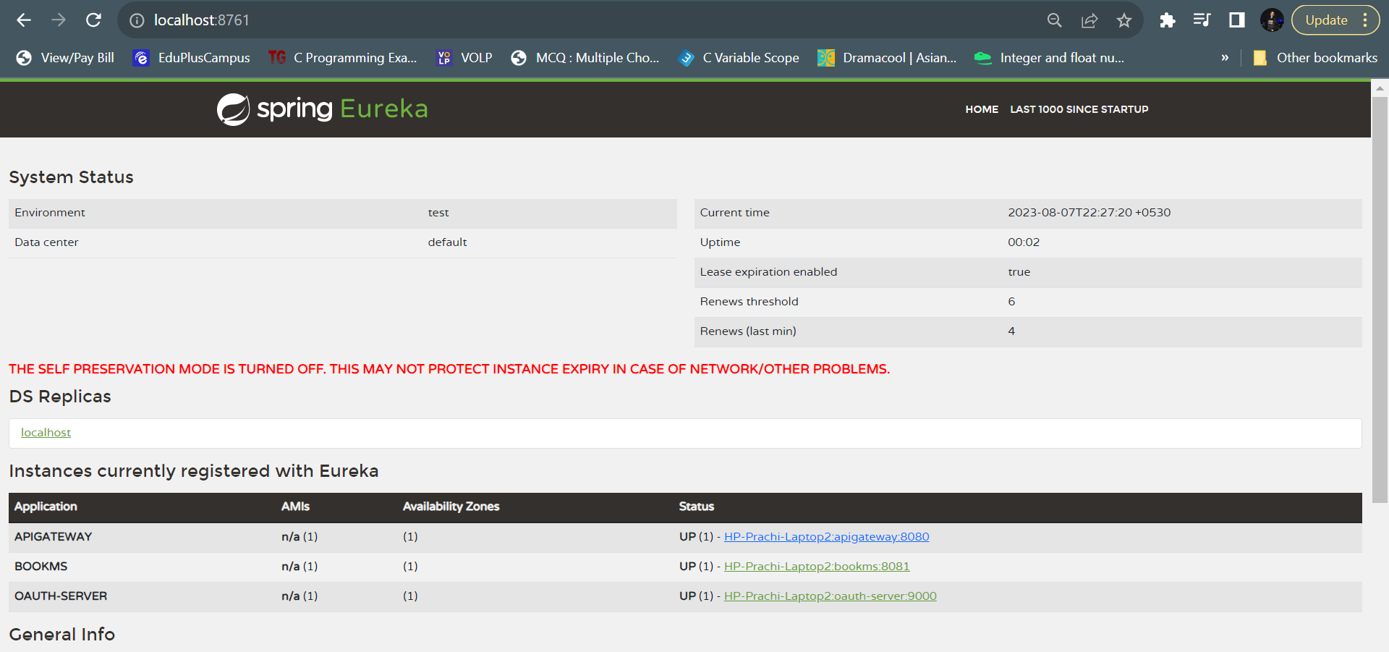

<http://localhost:8080/dummy-bookms/books>

As our auth server is up, we can access the books details due to wring credentials, we are getting 401 error (unauthorized request)

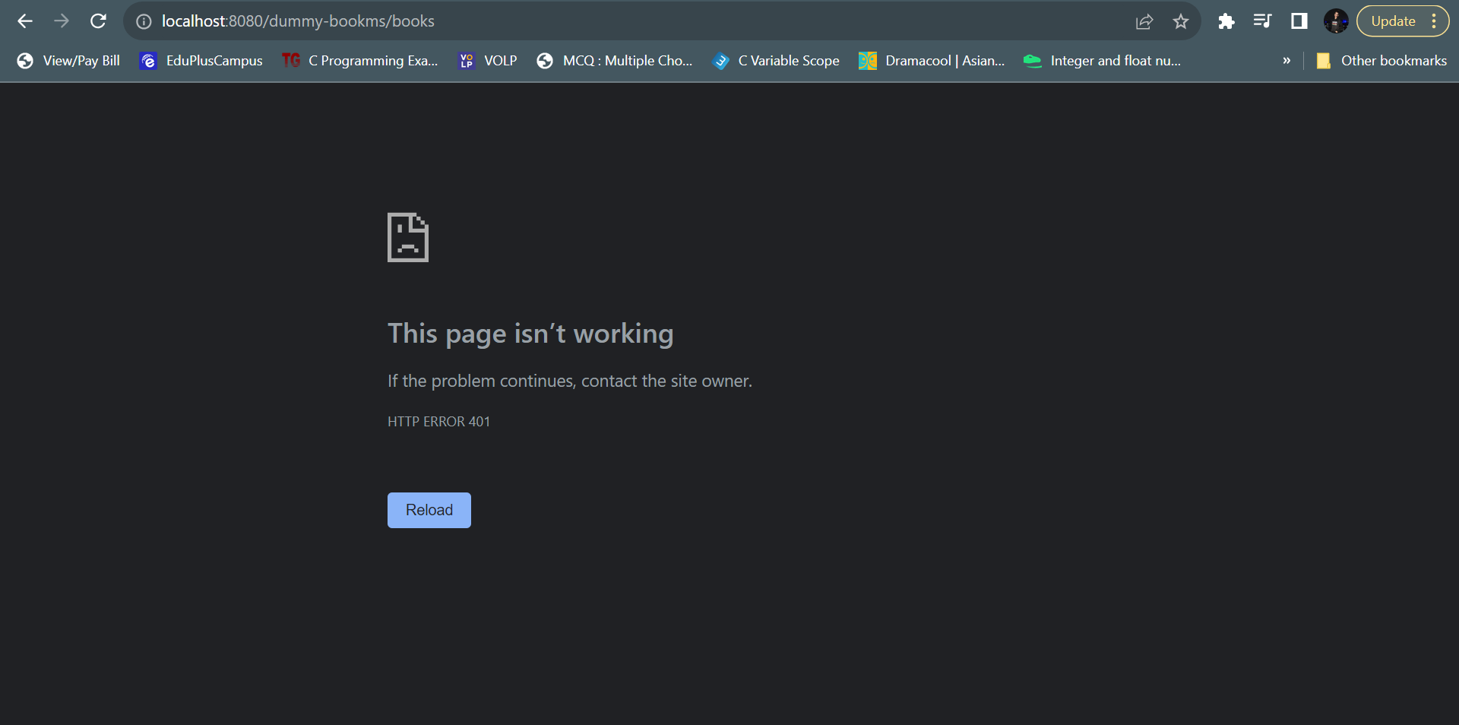

Hitting POST request on postman <http://localhost:9000/oauth/token>

We get an access token

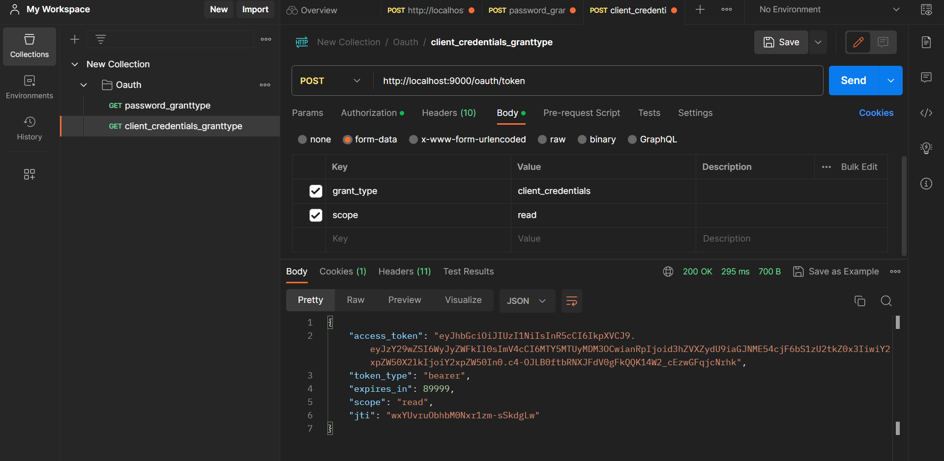

GET/localhost:8080/dummy-bookms/books/1

**Using access token** we can access book details, set the authorization type to “bearer token” and enter the access token as value for authorization in value.

